It is recommended to read the full instructions before installing the lighting system. If you have questions with regards to the installation, please contact the distributor who sold you the system or the manufacturer at info@thegallerysystem.com
NOTE: This system is designed as a DIY installation. The 12-volt output is very safe to handle. However, if you require any modifications to the 240-volt input (plug and lead for mains power), you are required by law to have an electrician perform the necessary modifications.
Need help to plan your system?
If you need help, send us a floor plan and indicate where you would like to place your track and lights. Include the location and height of available power points so we can give you an accurate quotation.

WHAT’S IN THE BOX – 300va Transformer Kit
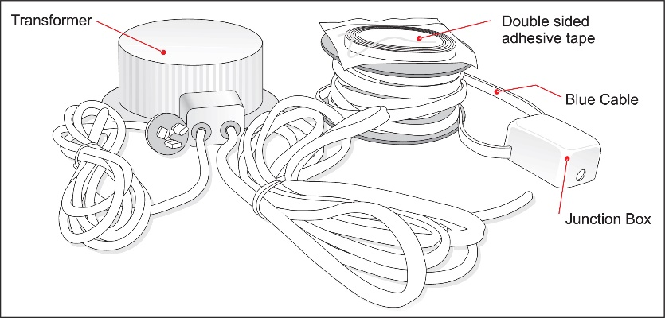

- 1 x transformer – with a 240 volt plug and lead (power input), and a black 12-volt cable (power output). The transformer reduces 240 volts mains power to a safe 12 volts.

- 1 x roll of blue power cable with a white junction box pre-connected.
NOTE: The blue power cable is wound in a continuous loop, with one end pre-connected to the right side of the white junction box and the opposite end pre-connected to the left side of the white junction box. The blue power cable needs to be cut to suit the lengths of track required. The exact method for cutting the cable will be discussed later in the instructions on page 3. The white junction box hides the connections of your blue power cable to the black 12-volt cable supplied from the transformer.
- 1 x roll of double sided adhesive tape – this holds the blue power cable firmly on top of the Gallery System track.

PLANNING YOUR SYSTEM

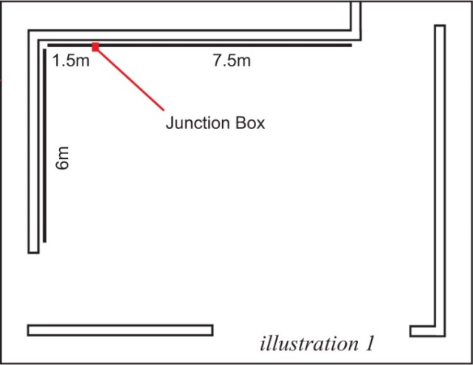
- As the system runs 12-volt lights, the power cannot travel as far as regular household 240 volts. This will affect where you place your white junction box. It is recommended to locate your white junction box as near to the middle of the system as possible.

- It is important NOT to install your track too high. For the lights to give the best effect on the art, we recommend installing the track no higher than 2.7m from the floor. If the track is installed too high, less light reaches the art and the oblique angle reduces the effectiveness of the light. Keeping the light close to the art will bring your art to life. Top View

- Larger installations may be divided into two or more systems, each with its own transformer. The number of transformers required will depend on the distance of track and number of lights required.

- Transformer installation options -

- You can screw the transformer to the wall and plug into a power point OR
- If you have an electrician installing the system, a power point can be installed above the ceiling with the option of carrying the black 12-volt cable inside or outside the wall to the junction box. If installed outside the wall use conduit to hide the cable (see directions page 3).

DIRECTIONS
Cutting the track and fitting the double-sided tape
The white junction box sits next to the track. This allows the blue power cable to run from the junction box out, onto and along the top of the Gallery System track. You need to allow a gap between the Gallery System tracks wide enough for the white junction box to fit between, using the white junction box supplied as a guide for the size of the gap. Cut the track to length with a hacksaw where required.
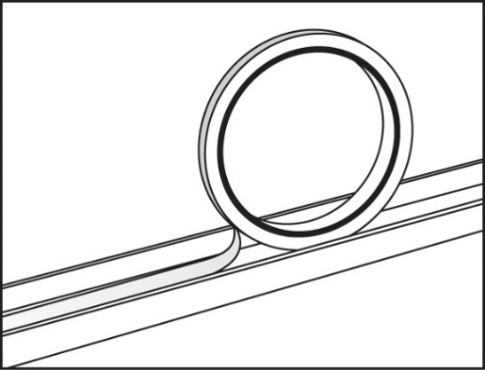
BEFORE SCREWING THE TRACK TO THE WALL – Fit the double-sided adhesive tape to the top surface of each length of Gallery System track as shown.
DO NOT remove the paper cover from the double-sided tape at this stage as the bare glue attracts dust and grit while fixing the track to the wall. Remove the paper from the tape after the track is installed.

Fixing the Track to the Wall
The top edge of the Gallery System track needs to be installed at least 15mm below the ceiling or cornice so there is room to fit the light wands. REMEMBER - leave a gap for the white junction box as previously mentioned. Screw the track to the wall using 25mm pan head self-tapping 8-gauge screws or similar, spaced 400mm to 500mm apart. It is recommended to screw into the wall studs and minimise the use of wall mates. For more details on fixing the track to the wall, go to www.thegallerysystem.com/directions
Install the transformer in the predetermined position – DO NOT TURN THE POWER ON AT THIS STAGE
NOTE: It is important that the transformer is well ventilated to avoid overheating.
The maximum distance the transformer can be installed from where the white junction box is to be fitted in between the Gallery System track is 3m (length of the black 12 volt cable).
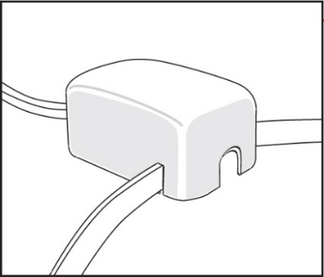
Fitting the Junction Box and Blue Power Cable
- Peel the paper cover from the double-sided adhesive tape you have already fitted into the top of the track.
- Unroll just enough blue power cable so the black reel sits on the floor (keep the blue power cable free of dirt) and the white junction box can be installed in the gap between the Gallery System tracks as per instructions 3 or 4 below.
The position of the white junction box between the tracks will be as follows –

- With the blue power cable (between the white junction box and transformer) positioned either at the top or the bottom of the white junction box (depending on whether the transformer is installed above or below junction box).
- The blue power cable which is wound onto the reel and pre-connected to the white junction box is to be aligned directly next to the horizontal surface on the top of the Gallery System track.

NOTE: Do not install blue power cable until the white junction box is firmly positioned in place as per 3 or 4 below.

- Fix the white junction box to the wall with the double sided tape on the back of the white junction box.
OR
- Fix the white junction box to the wall using screws - loosen the screws on the front cover of the white junction box. Remove the lid and using 6-gauge screws, screw the base plate of white junction box in place using the holes in the base of the box. Replace the lid, lining up the cables into the appropriate slots in the lid. Tighten the screws in the lid of the white junction box.

- Now the white junction box is in place, carefully push the blue power cable into the top of the Gallery System track along the right side first, gradually unrolling from the reel. Once the blue power cable is fitted into the full length of the Gallery System track to the right, cut the blue power cable in line with the end of the track. You can now gradually push the blue power cable into the Gallery System track to the left of the white junction box. If there is any cable left over, trim in line with the end of the Gallery System track.

NOTE: When installing the blue power cable into the top of the track, take care the cable lies straight and press down firmly.
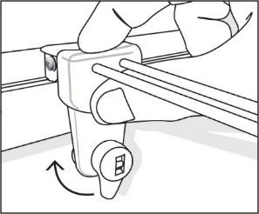
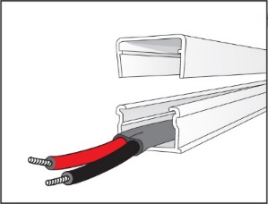
If there is any black 12-volt cable visible on the wall either above or below where the white junction box is located, it is recommended to use plastic conduit to hide the black 12-volt cable. Conduit is available from your local electrical wholesaler and it can be fixed to the wall using double sided adhesive tape. Fitting the Light Wands
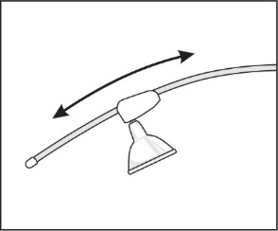
Fit the lamp into its socket on the light wand. Check the lever on the light wand is in the down position. Hold the wand up over the Gallery System track and lower it at a right angle to the track, holding your thumb firmly. Make sure the track fitting on the wand that connects to the Gallery System track is kept at a right angle to the track through the whole procedure. Once in position, turn the lever half a turn clockwise and, if your power is on, your lamp should now light up. VERY IMPORTANT: Make sure the light wand is held in the position described above, as installing on a slight angle will result in the light wand not making a connection with the blue power cable and the lamp failing to light up.
To adjust the angle of the light, simply slide the lamp socket fitting up or down the light wand. If you move your art to another position, simply remove the wand and move to the new position over your art.
Lamps
Using the correct lamps with the Gallery Lighting System is very important. Using low quality lamps or lamps higher than 20 watt output can become very hot and damage the plastics in the light wand or overload the transformer.
We recommend using the black Philips 7-watt Master LED lamps with black wands, and the silver Philips 5-watt LED lamps with the white wands. These lamps are warm white (3000k), have a 40,000 hour life and offer a broad 60 degree coverage of light over your art. With low heat emission, the LED lights will not damage your art.
Corner Covers
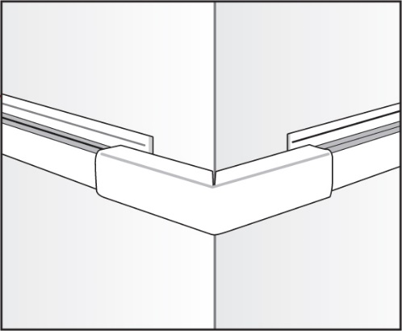
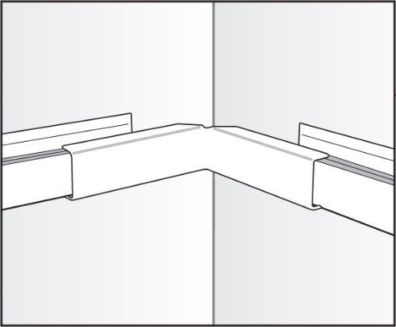
These covers hide the blue power cable where there are gaps in The Gallery System track and where the system is installed around corners. There are covers for inside corners, outside corners and small straight covers for any gaps in The Gallery System track. The covers are available in white or silver to match the track.
Inside Corner Covers Outside Corner Covers
Maintenance
To extend the life of your light wand it is important to wipe them over regularly to free them of dust. Dust on the light wands may result in the light wand to stop working correctly.

