Directions - Gallery Stainless Steel Cable System
1. First feed the wire cable through the track slides as shown.
2. Tilt the track slide to insert into the underside of the track (can be fitted at any point along the track).
3. Straighten the track slide so it sits level in the track.
4. The hanger is now captive and ready for the hook to be fitted.
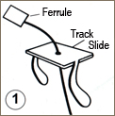 | 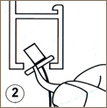 | 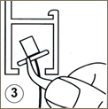 | 