Directions - Gallery Clear Tape System
- Pull tape from dispenser pack and cut off required length. Feed tape up through slot in the locking capsule and then back down through the same slot to form a large loop.
IMPORTANT: The short end must be to the front of the capsules as shown or the locking action
will fail.
- Swing the locking bar through the loop (A) of the tape as shown and press fully down.
Pull long end of tape (B) down to tighten the loop over the locking bar.
- Pinch the capsule firmly with your fingers and then insert into the end of the track as shown with the locking bar to the front.
- Fit the hook to the tape as shown.
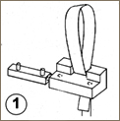 | 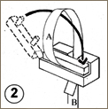 | 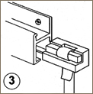 | 