Directions - Slimline Hangers

Both the Slimline Clear Tape and Stainless Steel Cable Hangers fit into the track in the same way as shown.
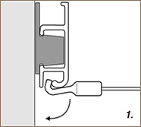 |  | 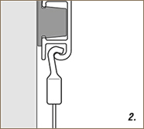
Insert in horizontal position. |  | Rotate to vertical position and it's ready to use.

As long as you do not exceed the maximum weight recommendations below you can hang two or more pictures on each hanger.

How strong is it?
Slimline Clear Tape Hangers
Recommended weight on one Slimline Clear Tape Hanger is 7kg (15lbs).

Slimline Stainless Steel Cable Hangers
Recommended weight on one Slimline Stainless Steel Cable Hanger is 15kg (33lbs).

