Slimline art hanging system
Directions - Slimline Track & Wall Anchors

NOTE: When installing the slimline track onto plasterboard walls, it is recommended it is secured to the wall by screwing into as many wall studs as possible. If it is not possible to line up with all available wall studs you can use plasterboard fittings (wallmates).  The wall anchors are used to fix the track to the wall. They butt up against the ceiling or cornice and should be spaced 20mm from each end and 400mm to 500mm apart. This allows for at least five wall anchors for every 2m length of Slimline track. Using any less than the recommended wall anchors is at your own risk. |  |  |  | 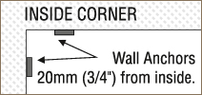
When continuing track around a corner fix the wall anchors as shown. |  |  |  | 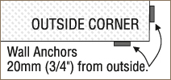
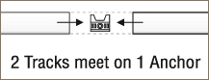 |  | When installing two or more lengths of track continuously along a wall we suggest you use just one wall anchor to support both track ends where they join. This will ensure the two ends are perfectly aligned.

Fixing to your wall
Plasterboard Walls: Hold the wall anchor butted up against the ceiling with its wings pointing upward. Fit an 8 gauge screw into the hole in the wall anchor and tap with a hammer to mark the screw position. Then drill on the mark using a 3mm drill (1/8").  If you strike a timber stud fix the wall anchor in place with a 25 x 8 gauge screw. |  | 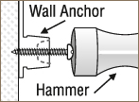
If there is no stud, drill the hole out to 6mm (1/4") and fit a "Wallmate" fitting. Then fix the wall anchor using a 25 x 8 gauge screw.  Once all the wall anchors are fixed to the wall, hold the track in place and snap onto the wall anchors. |  | 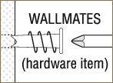
Masonry Walls: Hold the wall anchor firmly against the wall, butted up against the ceiling and using the anchor as a guide drill into the wall with a 4mm (5/32") masonry drill to a depth of 20mm (1") or so. Now redrill to a depth of 40mm (2") using a 6mm (1/4") masonry drill. Tap a 6mm (1/4") wall plug into the hole so the top is flush with the surface and fix the wall anchor in place with a 25 x 8 gauge screw. When the wall anchors are in position hold the track in place and snap the track onto the wall anchors.

