It is recommended to read the full instructions before installing the lighting system. If you have questions with regards to the installation, please contact the distributor who sold you the system or the manufacturer at info@thegallerysystem.com
NOTE: This system is designed as a DIY installation. The 12-volt output is very safe to handle. However, if you require any modifications to the 240-volt input (plug and lead for mains power), you are required by law to have an electrician perform the necessary modifications.
Need help to plan your system?
After reading the instruction you still require help, send us a floor plan and indicate where you would like to place your track and lights. Include the location and height of available power points so we can give you an accurate quotation.

WHAT’S IN THE BOX – 60 Watt Transformer Kit

- 1 x 60-watt transformer – with a 240 volt plug and lead (power input), and 3m blue power cable pre-connected to the white junction box (power output). The transformer reduces 240 volts mains power to a safe 12 volts.

- 1 x roll of blue power cable which is also pre-connected to the white junction (the white junction box hides the connections between the blue power cable so it enters neatly into the top of the Gallery System track).

- 1 x roll of double sided adhesive tape – this holds the blue power cable firmly into the top of the Gallery System track.

PLANNING YOUR SYSTEM

- As the system runs 12-volt lights, the power cannot travel as far as regular household 240 volts. This will affect where you place your white junction box. It is recommended to locate your white junction box at the end of the Gallery System track where the lights are to be installed.

- One 60-watt transformer will run a up to 8 x 7-watt LED lamps over a maximum distance of 9m of the Gallery System track.

- Larger installations may be divided into two or more systems, each with its own transformer. The number of transformers required will depend on the distance of track and number of lights required.

- It is important NOT to install your track too high. For the lights to give the best effect over the art, we recommend installing the track no higher than 2.7m from the floor. If the track is installed too high, less light reaches the art and the oblique angle reduces the effectiveness of the light. Keeping the light close to the art will bring your art to life.

Options for installing the transformer –

- You can screw the transformer to the wall or attach using the double-sided tape on the back and plug into the mains power.
OR
- If you have an electrician installing the system, a power point can be installed above the ceiling with the option of carrying the blue power cable inside or outside the wall to the junction box. If installed outside the wall use conduit to hide the cable (see directions page 4).

- Be mindful of the position of the transformer in relation to the junction box. From the junction box (sits at the end of the track) to the 240-volt plug is 4.45m.

DIRECTIONS

Cutting the track and fitting the double-sided adhesive tape
The white junction box sits next to the track. This allows the blue power cable to run from the junction box along the top horizontal surface of the Gallery System track. You need to allow a gap at the end of the Gallery System track wide enough for the white junction box to fit. Use the white junction box supplied as a guide for the size of the gap. Cut the track to length with a hacksaw where required.

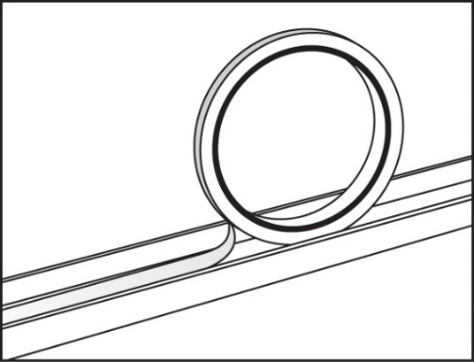
BEFORE SCREWING THE TRACK TO THE WALL – Fit the double-sided tape to each length of track as shown. It is much easier to fit the tape before the track is fixed to the wall.
DO NOT remove the paper cover from the tape at this stage. The bare glue attracts dust and grit while fixing the track to the wall. Remove the paper from the tape after the track is installed. Fixing the Track to the Wall
The top edge of the Gallery System track needs to be installed at least15mm below the ceiling or cornice so there is room to fit the light wands. REMEMBER to leave the gap for the white junction box as previously mentioned. Screw the track to the wall using 25mm pan head self-tapping 8-gauge screws or similar, spaced 400mm to 500mm apart. It is recommended to screw into studs and minimise the use of wall mates. For more details on fixing the track to the wall, go to www.thegallerysystem.com/directions
Install the Transformer in the predetermined position however, DO NOT TURN THE POWER ON AT THIS STAGE – From the junction box (sits at the end of the track) to the 240-volt plug is 4.45m.
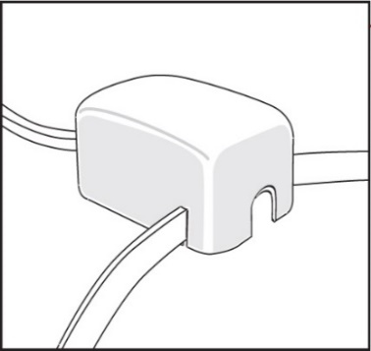
Fitting the Junction Box and Blue Power Cable
- Peel the paper cover from the double-sided adhesive tape you have already fitted into the top of the track.

- Unroll just enough blue power so the black reel sits on the floor (keep the blue power cable free of dirt) and the white junction box can be installed at the end of the Gallery System track as per instructions 3 or 4 below.

The position of the white junction box at the end of the track will be as follows -

- With the blue power cable (between the white junction box and transformer) positioned either at the top or the bottom of the white junction box (depending on whether the transformer is installed above or below junction box).
- The blue power cable which is wound onto the reel and pre-connected to the white junction box is to be aligned directly next to the horizontal surface on the top of the Gallery System track to either the left or the right of the junction box.
- Once the position of the junction box is determined, you may find that the blue power cable to be fitted to the top surface of the Gallery System track is exiting the white junction box in the wrong direction. If this is the case, loosen the two screws in the lid of the white junction box and remove lid. Redirect the blue power cable that is to be fitted to the top surface of the Gallery System track into the opposite slot in the lid. Replace the lid and tighten screws.

NOTE: Do not install blue power cable into the top of the track until the white junction box is firmly positioned in place as per 3 or 4 below.

- Fix the white junction box to the wall with double sided tape which is pre-installed on the back of the white junction box.

OR

- Fix the white junction box to the wall using screws - loosen the screws on the front cover of the white junction box. Remove the lid, and using 6-gauge screws, screw the base plate of the white junction box in place using the holes in the base of the box. Replace the lid, lining up the cables into the appropriate slots in the lid. Tighten the screws in the lid of the white junction box.

- Now the white junction box is in place, carefully push the blue power cable into the top of the Gallery System track, gradually unrolling from the reel. Once the blue power cable is fitted into the full length of the Gallery System track, cut any excess blue power cable in line with the end of the track.
NOTE: When installing the blue power cable into the top of the track, take care the cable lies straight and press down firmly.

If there is any blue power cable visible on the wall, either above or below where the white junction box is located, it is recommended to use plastic conduit to hide the cable. Conduit is available from your local electrical wholesaler and it can be fixed to the wall using double sided adhesive tape.
IT IS NOW SAFE TO TURN ON THE POWER TO THE TRANSFORMER
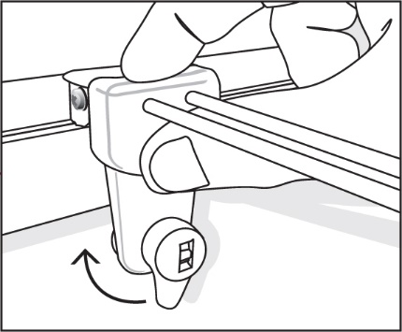
Fitting the Light Wands
Fit the lamp into its socket on the light wand. Check the lever on the light wand is in the down position. Hold the wand up over the Gallery System track and lower it at a right angle to the track, holding your thumb firmly. Make sure the track fitting on the wand that connects to the Gallery System track is kept at a right angle to the track through the whole procedure. Once in position, turn the lever half a turn clockwise and, if your power is on, your lamp should now light up.
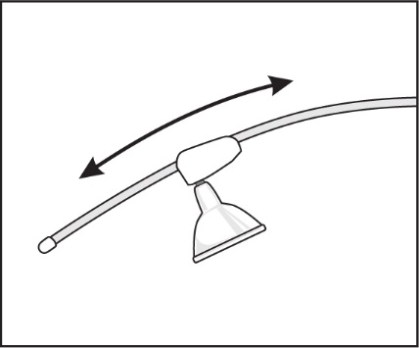
NOTE: It is very important to make sure the light wand is held in the position described above, as installing on a slight angle will result in the light wand not making a connection with the blue power cable and the lamp failing to light up.
To adjust the angle of the light, simply slide the lamp socket fitting up or down the light wand as shown in illustration 5. If you move your art to another position, simply remove the wand and move to the new position over your art.
Lamps
Using the correct lamps in The Gallery Lighting System is very important. Using low quality lamps or lamps higher than 20 watts, can become very hot and damage the plastics in the light wand or overload the transformer. It is recommended to use the black Philips 7-watt Master LED lamps with black wands, and the silver Philips 5-watt LED lamps with the white wands. These lamps are warm white (3000k), have a 40,000 hour life and offer a broad 60 degree coverage of light over your art. With low heat emission, the LED lamps will not damage your art.
Corner Covers
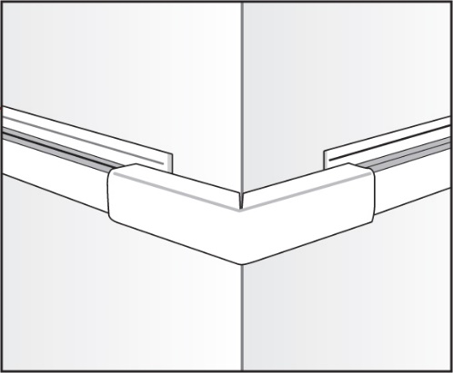
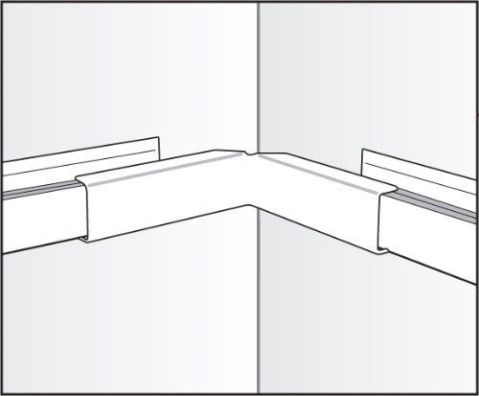
These covers hide the blue power cable where there are gaps in The Gallery System track and where the system is installed around corners. There are covers for inside corners, outside corners and small straight covers for any gaps in The Gallery System track. The covers are available in white or silver to match the track.
Inside Corner Covers Outside Corner Covers
Maintenance
To extend the life of your light wand it is important to wipe them over regularly to free them of dust. Dust on the light wands may result in the light wand to stop working correctly.

