PICTURE RAIL HANGERS

Gallery Systems provides residents of the UK with a premium quality picture rail system to hang artwork on your own traditional picture rails. To make a real impression it’s important to hang your artwork on your traditional picture rails correctly.
- Just feed the stainless steel cable into the hole in the Picture Rail Hook.
- Hang the Picture Rail Hook (with cable) onto your traditional picture rails.
- The Picture Rail Hook is designed so that it positions the cable close to the wall. This stops your art from leaning too far forward.
- Fit the adjustable hook (either the Standard Hook or the Push-Button Hook) as per Gallery Systems hook directions.

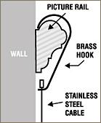 |  | 