Directions - Slimline End Caps and Covers

End Caps and Covers give a more finished look to the track ends.
To Cap the end of a single length of track
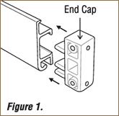 | 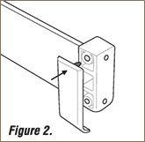
Push the End Cap into the end of the track as shown in Figure 1.
Snap the twin covers in two and fit the single cover into the End Cap as shown in Figure 2.
The curved part of the cover must face downwards.
To fit the End Cap to an outside corner
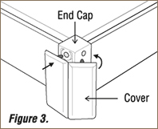 | 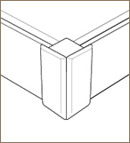
Push the End Cap into the end of the track as shown in figure 1.
Fit the hinged cover as shown in Figure 3.
Inside Corners don't expose the track ends so no cover is required.

