Directions - Slimline Mini Hooks

These hooks fit both the Slimline Clear Tape and the Stainless Steel Cable Hangers.
Directions:
Loosen the screw using the Allen key provided. Feed the end of the clear tape (or Stainless cable) through the hook body. Slide to the required position and tighten with the Allen Key.
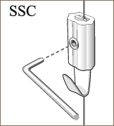
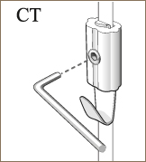

Recommended Weights:
Clear Tape 7kg (15 lbs) per hook. Stainless Steel Cable 15kg (33lbs) per hook.

