It is recommended to read the full instructions before installing the lighting system. If you have questions with regards to the installation, please contact the distributor who sold you the system or the manufacturer at info@thegallerysystem.com
NOTE: This system is designed as a DIY installation. The 12-volt output is very safe to handle. However, if you require any modifications to the 240-volt input (plug and lead for mains power), you are required by law to have an electrician perform the necessary modifications.
Need help to plan your system?
If after reading the instructions you still require help, send us a floor plan and indicate where you would like to place your track and lights. Include the location and height of available power points so we can give you an accurate quotation.

MICRO 60 KIT – INSIDE THE BOX

- 1 x 60-watt transformer – with a 1.45m x 240-volt plug and lead (power input), and blue power cable installed directly into the transformer. The transformer reduces 240-volts mains power to a safe 12-volts.
- 1 x 10m double sided tape to hold your blue power cable inside the track.

PLANNING YOUR SYSTEM

- As the system runs 12-volt lights, the power cannot travel as far as regular household 240-volts. This will affect where you place your transformer. It is recommended to locate your transformer at the end of The Gallery System track where the lights are to be installed.

- One 60-watt transformer will run a minimum of 2 and a maximum of 8 x 7-watt LED lamps over a maximum distance of 9m of The Gallery System track. If you wish to run 1 light, you will need to use our GE 20-watt halogen lamps.

- Larger installations may be divided into two or more systems, each with its own transformer. The number of transformers required will depend on the distance of track and number of lights required.

- It is important NOT to install your track too high. For the lights to give the best effect over the art, we recommend installing the track no higher than 2.7m from the floor. If the track is installed too high, less light reaches the art and the oblique angle reduces the effectiveness of the light. Keeping the light close to the art will bring your art to life.

Options for installing the transformer –

- You can screw the transformer to the wall or attach using the double-sided tape on the back and plug into the mains power.
OR
- If you have an electrician installing the system, a power point can be installed above the ceiling with the option of carrying the blue power cable inside or outside the wall to the junction box. If installed outside the wall use conduit to hide the cable (see directions page 4).

- Be mindful of the position of the transformer in relation to The Gallery System track where the lights are to be installed. You have a set length of blue power cable connected to the transformer (see length on cable packaging) and a 1.45m x 240-volt lead and plug for the mains power point.

DIRECTIONS
Cutting the track and fitting the double-sided adhesive tape
The blue power cable will run directly from your transformer along the top horizontal surface of The Gallery System track. You need to allow a gap at the end of The Gallery System track wide enough for the transformer to fit. Use the transformer as a guide for the size of the gap. Cut the track to length with a hacksaw where required.
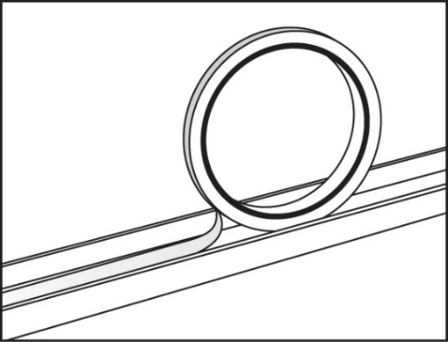
BEFORE SCREWING THE TRACK TO THE WALL – Fit the double-sided adhesive tape to the track as shown. It is much easier to fit the tape before the track is fixed to the wall.
DO NOT remove the paper cover from the double-sided adhesive tape at this stage. The bare glue attracts dust and grit while fixing the track to the wall. Remove the paper from the tape after the track is installed. Fixing the Track to the Wall
The top edge of the Gallery System track needs to be installed at least 15mm below the ceiling or cornice so there is room to fit the light wands. REMEMBER to leave the gap for transformer as previously mentioned. Screw the track to the wall using 25mm pan head self-tapping 8-gauge screws or similar, spaced 400mm to 500mm apart. It is recommended to screw into studs and minimise the use of wall mates. For more details on fixing the track to the wall, go to www.thegallerysystem.com/directions

Fixing the Transformer and the Blue Power Cable
- Install the Transformer in the predetermined position. However, DO NOT TURN THE POWER ON AT THIS STAGE.
- Peel the paper cover from the double-sided adhesive tape you have already fitted into the top of the track.
- Unroll the blue power cable, mindful to keep it free of dirt. Carefully push the blue power cable into the top of The Gallery System track. Once the blue power cable is fitted into the full length of The Gallery System track, cut any excess blue power cable in line with the end of the track.
NOTE: When installing the blue power cable into the top of the track, take care the cable lies straight and press down firmly.

IT IS NOW SAFE TO TURN ON THE POWER TO THE TRANSFORMER
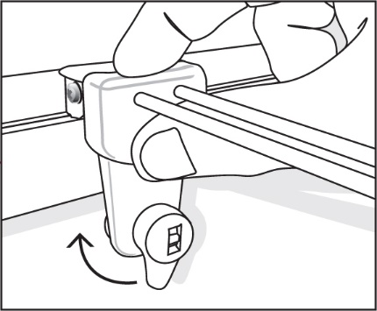
Fitting the Light Wands
Fit the lamp into its socket on the light wand. Check that the lever on the light wand is in the down position. Hold the wand up over The Gallery System track and lower it at a right angle to the track, holding your thumb firmly. Make sure the track fitting on the wand that connects to The Gallery System track is kept at a right angle to the track through the whole procedure. Once in position, turn the lever half a turn clockwise and, if your power is on, your lamp should now light up.
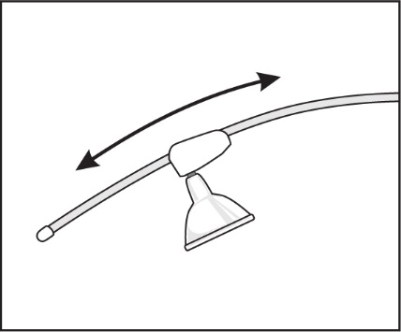
NOTE: It is very important to make sure the light wand is held in the position described above, as installing on a slight angle will result in the light wand not making a connection with the blue power cable and the lamp failing to light up.
To adjust the angle of the light, simply slide the lamp socket fitting up or down the light wand as shown. If you move your art to another position, simply remove the wand and move to the new position over your art.
Lamps
Using the correct lamps in The Gallery Lighting System is very important. Using low quality lamps or lamps higher than 20-watts, can become very hot and damage the plastics in the light wand or overload the transformer. It is recommended to use the black Philips 7-watt Master LED lamps with black wands, and the silver GE 7-watt LED lamps with the white wands. These lamps are warm white (3000k), have up to a 40,000 hour life and offer a broad 60 degree coverage of light over your art. With low heat emission, the LED lamps will not damage your art.

Corner Covers
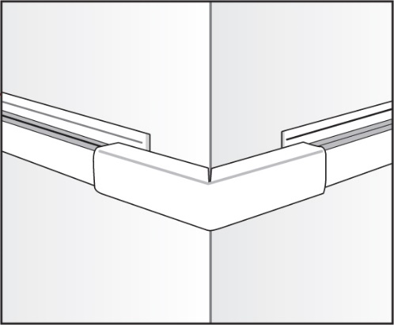
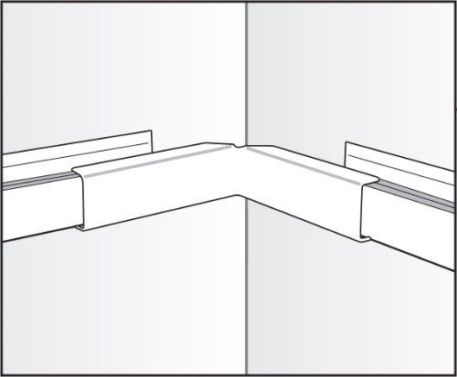
These covers hide the blue power cable where there are gaps in The Gallery System track and where the system is installed around corners. There are covers for inside corners, outside corners and small straight covers for any gaps in The Gallery System track. The covers are available in white or silver to match the track.
Inside Corner Covers Outside Corner Covers

Maintenance
To extend the life of your light wand it is important to wipe them over regularly to free them of dust. Dust on the light wands may result in the light wand to stop working correctly.

